RULES AND REGULATIONS REQUIRED

BY CAESARS PALACE

Catering, Food & Beverages
Caesars Palace Catering Department is the exclusive caterer for all patrons in that Caesars Palace retains the exclusive rights for all food and beverage services therein. It is not permissible to bring food or beverage into the facility. This includes items for personal consumption. Failure to comply with this policy will result in a corkage fee in addition to any other damages to Caesars Palace may be entitled.

General Facility Regulations

Balloons: To display balloons, you must have approval from show management prior to move-in. Please submit requests in writing to Marguerite.Hoffman@bobit.com. The exhibitor will be responsible for labor, equipment, and damage fees to retrieve balloon or repair damages should balloons become loose.

Electrical: Encore Event Technologies is the exclusive provider for all electrical requirements. Electrical wiring must be handled by Encore. Any equipment installation must conform to appropriate Las Vegas, Nevada codes. Hotel personnel are obligated to refuse connections where wiring is not in accordance with subject code. Material not conforming to such regulations will be removed immediately at the exhibitor’s expense.

Fire Code: The Clark County Fire Department reserves the right to enter the premises and enforce fire codes and regulations at their discretion.

Fire Extinguishers/Fire Hose Cabinets: Please remember that all fire extinguishers and fire hose cabinets must be kept clear, accessible, and remain free of obstruction at all times.

Signs and Decorations: Signs or banners may not be taped, stapled, nailed, tacked or otherwise affixed to any hotel doors, walls, columns, or other parts of the building or furnishings. Nothing is to be placed against or leaned against any wall in the convention halls. Signage or banners may not be attached to the moveable wall tracks at any time.

Smoking: Smoking is prohibited in the Convention Facilities. This includes traditional cigarettes, cigars, vapors, and e-cigarettes.

RULES AND REGULATIONS FOR ALL BOOTH TYPE DISPLAYS AS OUTLINED BY IAEE
If you are unsure about your booth type please call Exhibitor Customer Service at (310) 717-0633.

In-Line (Linear) Booth
- Arranged in a straight line
- 10ft wide X 10ft deep
- 8ft high back wall/drape
- 4ft high side rail/drape
- One side is exposed to the aisle
- Adjoining booths to the right and left and shares a common back wall with another in-line booth
- Can be combined to create larger in-line booths, e.g. 10ft X 20ft or 10ft X 30ft

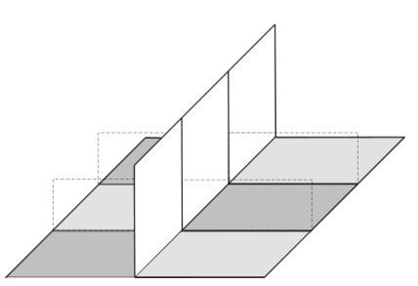
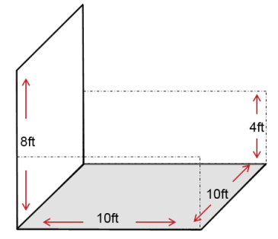

DISPLAY RULES
Line of Sight
- Obstructing the line of sight to other booths is prohibited.
- Displays and objects that create a visual wall over 4ft tall must be placed within in the back half (i.e. back 5ft) of an in-line booth.
- Materials that create a visual wall are at the discretion of show management and include, but are not limited to items such as pop-up displays, banners, backdrops, shelving units, large machinery, and large plants/shrubbery.
- Materials that do not create a visual wall are at the discretion of show management and may include items such as literature racks and floor lamps. These items are OK in the front 5ft of an in-line booth.

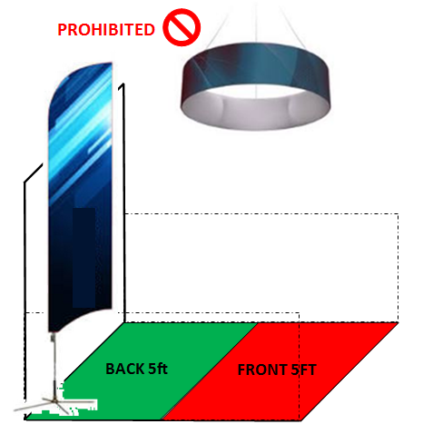
Prohibited items
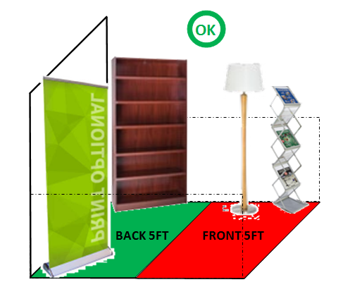
- Hanging banners
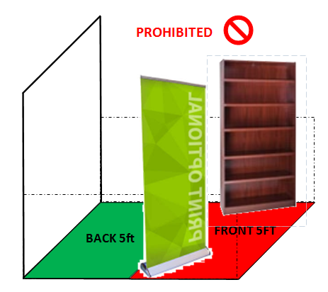
- Objects taller than 8ft

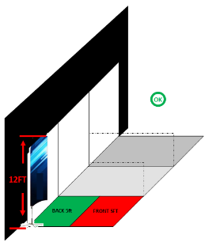

Perimeter Booth
- An in-line booth with the back wall positioned against the perimeter wall of the exhibit hall.

DISPLAY RULES
- Adheres to the same display rules as an in-line booth except the maximum height of an object or back wall can be 12ft.

Split Island Booth
- 20ft X 20ft or larger
- Exposed to the aisle on 3 sides
- May share a common back wall with another split island booth
Be nice to your neighbors

DISPLAY RULES
- Booths with a vehicle must adhere to all rules and regulations for vehicle displays.
- Back wall structure must be finished on the backside and cannot show images, copy, or content of any kind.
- A maximum height range of 16ft is permitted for floor standing items.
- Banner hanging is permitted and will be hung at the height of 16ft from the floor to the bottom of the banner. The banner must be hung directly over the booth and back 10ft from neighboring booths.
- Double-sided or rotating banners, signs, and graphics must be set at least 10ft away from other booths.
- Do not remove the tape marking your booth space. A representative from the general contractor will remove the tape or must give you approval to remove it.
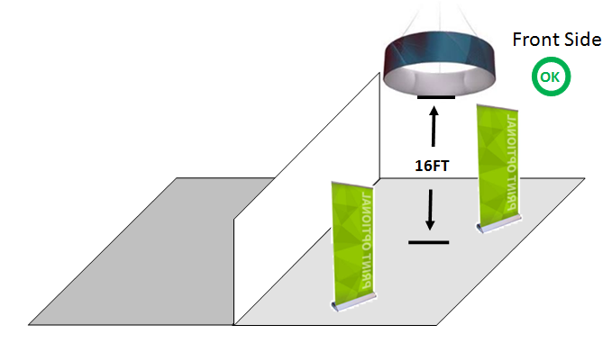

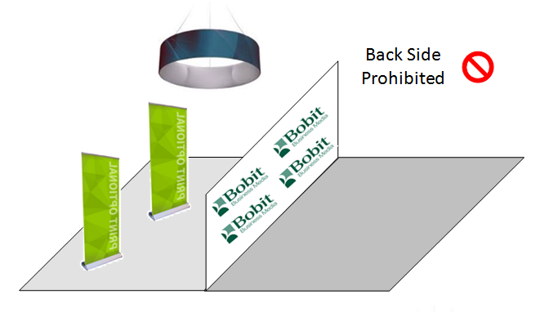
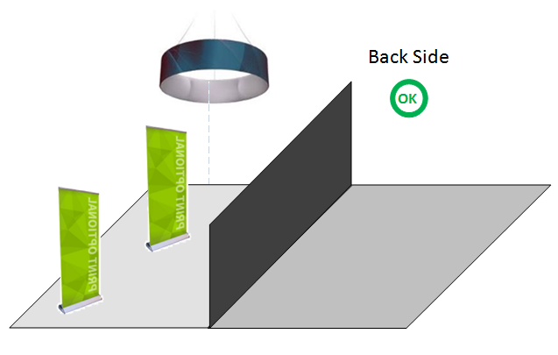
Island Booth
- 20ft X 20ft or larger
- Exposed to the aisle on all 4 sides

DISPLAY RULES
- Booths with a vehicle must adhere to all rules and regulations for vehicle displays.
- A maximum height range of 16ft is permitted for floor standing items.
- Banner hanging is permitted and will be hung at the height of 16ft from the floor to the bottom of the banner. The banner must be hung directly over the booth and back 10ft from neighboring booths.
- Double-sided or rotating banners, signs, and graphics must be set at least 10ft away from other booths.
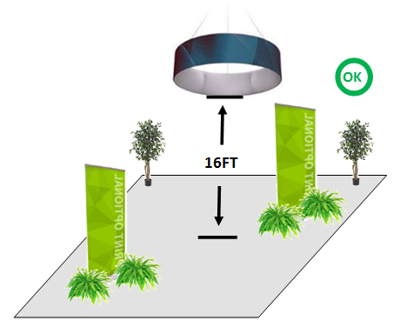

Be nice to your neighbors

Multi-Story Exhibit, Towers, Canopies, Ceilings and Similar Coverings
- Fire and safety regulations vary from facility to facility and these structures may not be permitted. Please contact show management for further information.
- All multi-story exhibits, towers, canopies, ceilings and similar coverings must be approved by show management.

Americans with Disabilities Act (ADA)
- All exhibiting companies must be compliant with the ADA. Compliance information can be found at www.ada.gov.
- Exhibitors should be sensible and accommodating. Examples include:
  - Raised flooring should be wheelchair accessible by a ramp with a grade no steeper than 1:12 and does not extend into the aisle
  - Interactive displays, such as touch screens, should be positioned to accommodate a person in a wheel chair
  - Provide the same attendee experience in all areas of the exhibit space (including multi-story exhibits)
  - Have printed copies of audio presentations for those who are hearing impaired
  - Have audio presentations available for those with sight impairment

Banner Hanging
Banner hanging is permitted for perimeter, island and split island booths (see pages 12-13). Banners will be hung at the height of 16ft from the floor to the bottom of the banner, directly over the booth, and back 10ft from neighboring booths.

Shepard Exposition Services is contracted to hang banners that weigh 200lbs or less. SES is contracted to hang banners over 200lbs. Both banner hanging order forms can be found in the service kit. Here are two other important considerations.

Banner Delivery:
- Overhead hanging signs should be shipped in a separate container directly to the Advance Warehouse using the Advance Hanging Sign shipping label included in the service kit.
- The container must arrive no later than the Advance Warehouse shipping deadline of March 3, 2017. If these procedures are not followed the hanging of your sign cannot be guaranteed.

Demonstrations and Solicitations
- All sales presentations, product demonstrations, etc. must be conducted within the confines of the contracted space so that both exhibitors and attendees are fully in the booth and do not spill into the aisle or other exhibit space. This includes setting tables and chairs away from the front of the booth so all business takes places within the contracted space.
- For demonstrations involving moving parts or are otherwise potentially dangerous, exhibitors must establish a minimum distance of 3ft between the product and spectators or install hazard barriers to prevent accidental injury.
- All exhibitors, including hired talent, must remain in the contracted booth space and are not permitted to solicit business or distribute sales materials, literature, or promotional items outside of the contracted booth space.
- Exhibitors are prohibited from placing product, literature, and promotional items on tables and other surfaces outside of their contracted booth space. Items found outside of the contract booth space will be discarded.

Exhibit Properties
- All exhibit properties including tables, banners, plants, and literature racks must be placed within the borders of your contracted space and cannot encroach on the aisles.

Lighting
- Lighting fixtures, trusses, and overhead lighting must be placed within the contracted exhibit space. Hanging lights must be approved by show management.
- Gobos and other lighting projections must be aimed toward the contracted booth space and not onto the aisle or other exhibits.
- Potentially harmful lighting that can trigger photosensitive epilepsy must be approved by show management. This includes lasers, ultraviolet lights, strobes, and flashing lights.
- Specialized lighting effects should be in good taste and cannot interfere with neighboring exhibitors or detract from the general atmosphere of the event.
- Quartz halogen lighting fixtures may not be permitted. Check with show management to prevent any issues upon move-in.

Sound/Music
- Sound and music equipment are permitted as long as it does not disrupt neighboring exhibitors. The sound level is at the discretion of show management and you may be asked to turn down the volume.
- Speakers must be placed to direct sound into the contracted booth space and not into the aisle.

Storage
- Exhibitors are prohibited from storing excessive product, literature or empty packages behind drape and under tables. You may store a small quantity under a table if it is out of eyesight for attendees.
- Exhibitors must store empty packages and excess materials that cannot fit under the table and out of eyesight with the general contractor. Storing empty crates and boxes is included with your material handling fee- simply obtain an “Empty” sticker from the service desk and affix it to your empty crate or box.

Structural Integrity
- All exhibits must be able to endure normal contact and vibrations imposed from other exhibitors, hall laborers and installation/dismantle equipment. This includes moderate wind that may be caused by open freight doors.
- It is the responsibility of each exhibitor to ensure their display fixtures are installed properly and can adequately withstand its intended use.
- All exhibitors agree to adhere to local fire, safety and environmental regulations.

