May 15 – 18. 2022
Caesars Palace
Las Vegas, NV

Exhibitor Service Kit

Dear Agent Summit Exhibitor,

Thank you for choosing to exhibit at Agent Summit 2022 being held at Caesars Palace.

We are pleased to provide you with our easy-to-use Exhibitor Service Kit. The kit is complete with a checklist of the pertinent services needed to ensure a successful and productive exhibition for your company.

EXHIBITOR STAFF REGISTRATION PROCEDURES
Exhibitors will be allotted a certain number of complimentary conference badges. Please refer to your exhibitor agreement for your specific allotment. The badge form has been designed to register your staff. If you go over your allotment of badges for staff, you will need to purchase additional passes for $945.00 per person.

BADGE PICK-UP COUNTER
Exhibitor badges will not be mailed. Badges will be available for pick-up at the Agent Summit Registration Counters starting on Sunday evening, May 15, 2022 at 5:00pm. Please check the online agenda for specific registration hours. Staff that are on site solely for the purpose of installing or dismantling your booth do not need an exhibitor badge from your allotment. Instead they will be required to wear a temporary worker pass that is valid for move-in and move-out hours only. Temporary worker passes can be picked up at the registration counters.

SHOW CONTRACTOR
We are excited to have Shepard Exposition as our contractor. Shepard provides excellent customer service and the same products and services that you are familiar.

We can call you to personally review all deadlines and assist you with filling out mandatory show management forms. Many of the services provided are time-sensitive and offer pre-show discounts . . . read this kit carefully!

If you have questions pertaining to the material enclosed, please contact me directly at 310-717-0633 or by email at Marguerite.Hoffman@bobit.com.

Sincerely,

Marguerite Hoffman
Event Manager

Step-By-Step Guide

- Print the Print & Post Quick Reference sheet on page 4 and keep it handy.
- Plan your exhibit using the checklist on page 10 and online at www.agentsummit.com/service-kit.
- Complete your forms by the deadlines!
- Verify you have completed all items on your checklist.

Tips
- Read all emails from Show Management.
- Be sure to order by the discount deadlines for the best rates.
- Use www.agentsummit.com as a resource where you’ll find:

  - Current Floor Plan: Check out the latest configuration.

  - Sponsorship Information: From bag stuffers to networking events, investing in a sponsorship opportunity will increase your onsite exposure.

  - Seminar Schedule: Don’t forget that your exhibitor badge includes the seminars. Attend these to get a better understanding of your clients’ needs.

Print and Post Quick Reference Sheet
Exhibit Hall Schedule
Sunday, May 15 5:00pm - 6:30pm Welcome Reception: Badge Pick up and Happy Hour
Exhibitor Move-In
Sunday, May 15 12:00pm - 6:00pm Exhibitor Move-In
Monday, August 30 8:00am - 11:00am Exhibitor Move-In
Exhibit Hall Hours
Monday, May 16 8:00am - 9:00am Exhibit Hall Open and Breakfast
11:50am - 1:00pm Exhibit Hall Open and Lunch
4:30pm - 6:30pm Opening Reception in the Exhibit Hall
Tuesday, May 17 8:00am - 9:00am Exhibit Hall Open and Breakfast
12:00pm - 1:20pm Exhibit Hall Open and Lunch
4:15pm - 6:15pm Exhibit Hall Open and Evening Reception
Exhibitor Move Out
Tuesday, May 17 6:15pm - 10:00pm Exhibitor Move-Out (Early dismantle prohibited)

Note: All exhibits must be fully removed from the exhibit hall by 10:00pm on Tuesday night.
Important Deadlines Snapshot: All deadlines are not included below; review the kit for additional deadlines.
Deadline | Form or Information | Contractor/Vendor
April 15, 2022 | First Day for Shipments to Arrive at Advance Warehouse | Shepard Exposition Services
April 25, 2022 | Shepard Discount Services (Booth Rentals, Rental Accessories, Specialty Flooring, Non Hanging Signs/Graphics) | Shepard Exposition Services
April 25, 2022 | Shepard Discount Services (Carpet, Furniture, Installation & Dismantle Labor) | Shepard Exposition Services
April 29, 2022 | Hotel Room Discount Deadline | Caesars Palace
May 13, 2022 | Last Day for Shipments to Arrive at Advance Warehouse | Shepard Exposition Services

Fraud Warning

Agent Summit is committed to providing you with the best services and travel deals around. Bobit Business Media are the official providers for Agent Summit and works with the approved official contractors listed below.

THE ONLY HOTEL WAY TO BOOK A HOTEL ROOM FOR OUR EVENT IS THROUGH OUR WEBSITE OR
CALLING THE HOTEL DIRECTLY. https://www.agentsummit.com/venue/hotel
WE WILL NOT SOLICIT YOU TO PURCHASE LISTS OF ATTENDEES OR INDUSTRY PROFESSIONALS.

OFFICIAL APPROVED CONTRACTORS
Caesars Palace
cVent
Encore Global
Garda Security
Rainprotection Insurance
ELITeXPO
ExpoEase
Shepard Exposition Services

EXHIBITOR FRAUD WARNING!

Any offers from other third-party vendors or travel agencies are not endorsed by Agent Summit. These offers can be in the form of list rentals, e-mail blasts, ePromos, housing, travel- the list goes on. Don’t be fooled by offers from other parties using the Agent Summit name – they are NOT affiliated with Agent Summit, Bobit Business Media or MG Investment Group.

Below is a list of fraudulent companies that are known to target exhibitors, sponsors and attendees. Be aware there are many more scammers out there and if the offer seems too good to be true, it probably is. At the very least, please check the prospective vendor’s rating at www.bbb.org.
If you are contacted by a company you suspect to be fraudulent please contact
Marguerite.Hoffman@bobit.com or call 310-717-0633

APPROVED Contractor List
Please take a moment to read this important warning to all Agent Summit exhibitors. Below is a list of Agent Summit Approved Contractors. No other approved contractors will solicit you directly. If you are contacted by a company not listed below and you would like to check the validity, please email marguerite.hoffman@bobit.com

Audio Visual/Electrical/Internet
Encore
Phone: 702-866-1133
caesarspalaceexpo@encoreglobal.com

Catering
Erin Bauer
Caesars Palace
Phone: 702-407-6020
Ebauer@caesars.com

Decorator/Furniture
Shepard Exposition Services
Contact: Customer Service
5845 Wynn Rd., Suites A, B, C, D
Las Vegas, NV 89118
Phone: (702) 507-5278
Fax: (702) 948-0341
EVENT CODE: L141580821
lasvegas@shepardes.com

Florist
Expo Ease
6 E. Charleston
Las Vegas, NV 89104
Phone: 702-368-2868
info@expoEase.com
www.expoease.com

Freight
ELITeXPO
Phone: 800-543-5484
Email: sales@elitexpo.com
www.eliteexpo.com

Hotel Reservations
Caesars Palace
3600 S Las Vegas Blvd
Las Vegas, NV 89109
Ph: 1-888-987-6667
Mention code SAGE0821BE

Internet Services
Encore
Phone: 702-866-1133
caesarspalaceexpo@encoreglobal.com

Shipping & Receiving
* Shipping labels provided in the Shepard Service Kit
ADVANCE WAREHOUSE
[Exhibiting Co. & Booth #]
Agent Summit
c/o Shepard Exposition Services
5845 Wynn Rd., Suites A,B,C,D
Las Vegas, NV 89118
Phone: 702-507-5278
Fax: 702-948-0341
lasvegas@shepardes.com
EVENT CODE: L116190522
Shipping Dates:
April 15, 2022 – May 9, 2022 *Shipments received after May 9, 2022 will incur a surcharge for late delivery

Agent Summit Contact Information

Show Management
Marguerite Hoffman
Event Manager
Phone: (310) 717-0633
Fax: (310) 533-2511
Marguerite.Hoffman@bobit.com

Sponsor Fulfillment
Marguerite Hoffman
Event Manager
Phone: (310) 717-0633
Fax: (310) 533-2511
Marguerite.Hoffman@bobit.com

Education/ Speaker Management
Kate Spatafora
Managing Editor
Phone: 631-561-7586
kspatafora@mgigmedia.com

Exhibit & Sponsor Sales
David Gesualdo, Show Chairman
Agent Summit
Phone: (727) 947-4027
Fax: (310) 388-6061
dgesualdo@mgigusa.com

Eric Gesualdo, National Sales Director
Agent Summit
Phone: (727) 612-8826
egesualdo@mgigusa.com

Registration
Martina Gombalova
Phone: (727) 686 2893
mgombalova@mgigusa.com

Exhibit HALL & BOOTH OVERVIEW

The Exhibit Hall is located in Palace Ballroom within the Caesars Palace.

Here is a basic overview of your exhibit space.

- Booth Drape: All booths will have the following drape (excluding island booths):
  - Back Drape: White
  - Side Rail: White

Booth Type: Refer to your exhibitor/sponsorship agreement for your booth type. If you’re unsure about what is included in your booth call show management at (310) 717-0633 or email Marguerite.Hoffman@bobit.com

  - Standard Booths Include : Drape and 7” x 44” ID sign
*Your exhibit booth does NOT include a skirted table, chairs or wastebasket unless your space agreement specifically states you upgraded to a booth “Package.”

- Carpet:
  - IMPORTANT! The exhibit hall is carpeted, but booth carpet is NOT mandatory. If you choose to have carpet, each exhibitor must order carpet through Shepard Exposition Services unless you bring your own.

- Hanging Signs are permitted in the Ballroom, and must be installed by Encore (see official vendors).

Exhibit Hall Floor Plan
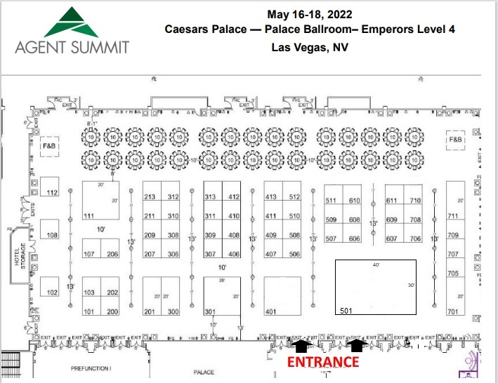
* As of 2/2/22

Booth Planning Checklist
The following items are suggested items that are popular among exhibitors and may not apply to you. Contact the corresponding contractor to order what you need for your exhibit booth. More great rentals and services can be found through the Agent Summit online service kit.

Note: If you upgraded your space to include a booth package you will be provided (1) 6ft table with black skirt,
(2) side chairs, and (1) wastebasket. If you’re not sure if you have a booth package please call customer service at the number below.

Popular Items | Vendor | Order Form
¨ Carpet – NOT Mandatory | Shepard Exposition Services | Shepard Service Kit
¨ Table with skirt | Shepard Exposition Services | Shepard Service Kit
¨ Chairs | Shepard Exposition Services | Shepard Service Kit
¨ Wastebasket | Shepard Exposition Services | Shepard Service Kit
¨ Furniture and Booth Accessories | Shepard Exposition Services | Shepard Service Kit
¨ Booth Cleaning | Shepard Exposition Services | Shepard Service Kit
¨ Electrical | Encore Global
¨ Internet | Encore Global
¨ Audiovisual (e.g. monitors) | Encore Global
¨ Floral | Expo Ease | Expo Ease Direct Ordering
¨ Lead Retrieval/ Badge Scanners | Cvent
¨ Freight Carrier | ELITExPO | ELITExpo Order Form

General Show Information & Rules A- Z
In addition to the following general rules and information, please review the Exhibit Display Rules and Facility General Policies and Procedures.

Each exhibitor will be responsible for knowing and adhering to all policies and procedures outlined by show management and Caesars Palace.

AUDIO/VISUAL
Exhibitors requiring audiovisual can make arrangements with Encore Global

ARRANGEMENT OF EXHIBITS
Agent Summit will provide display space as indicated on the official floor plan, insofar as possible, but reserves the right to make any changes necessary in the interest of an exhibitor. The current floor plan can be found online at http://www.AgentSummit.com.

BALLONS
Mylar balloons are prohibited. Latex balloons inside the facility must remain “tethered” to a fixed object. The balloon may be no larger than thirty-six inches (36”) in diameter. You must have approval to display balloons from your Event Service Manager prior to move-in. There is a labor and equipment charge to retrieve balloons in the ceiling should they become loose.

BANNER/SIGN HANGING
Banner and sign hanging is allowed and can be ordered with Encore Global.

BOOTH DECORATION
Shepard Exposition Services is the Official Service Contractor for Agent Summit.

The exhibit hall is carpeted and it is NOT mandatory for exhibitors to carpet their booth. Carpet order must be placed through Shepard or exhibitors may bring their own.

Each 10’ x 10’ space will be provided with the following:
- 8’ Back Drape, 3’ Side Rail (in-line booths only)
- Back Drape Color: Teal & White, Side Rail: White
- 7” x 44” One Line Company Identification Sign (in-line booths only)

If you upgraded your space agreement to a booth package you will also be provided with:
- (1) 6’ table with black skirt, (2) side chairs and (1) waste basket

If you’re unsure what is included with your booth call show management at (310) 717-0633.
Note: On-site prices will be at least 25% higher and you can encounter delays to have your order filled. Pre-order and save time & money!

BUSINESS CENTER
The FedEx Office if a full service business center within the hotel. Office hours vary.
CANCELLATION
Payment is refundable if Agent Summit is notified in writing at least 90 days prior to the event, less a $300 processing fee. Cancellation policy applies to all exhibiting firms. Failure to appear at the exposition does not release the exhibitor from the responsibility for payment of the full cost of space rented.

CARPET – NOT MANDATORY
The exhibit hall is carpeted, but booth carpet is NOT MANDATORY. Each exhibitor must order carpet through Shepard Exposition Services unless you bring your own. The exhibit hall aisle carpet color is peacock (teal and black).
CONTRACTED LABOR
All exhibitors must observe prevailing union regulations regarding use of union operators for equipment. Please review the Union Rules found in the Shepard kit.

EARLY TEARDOWN
Teardown before the show is over is strictly prohibited. Any exhibitor violating this policy will be fined show points for the following show or any of the Bobit Business Media Events. Please consider this when making travel plans. Exhibitor move-out is Tuesday, May 17th from 6:15pm – 10:00pm.

ELECTRICAL CONTRACTOR
Encore Global is the official electrical provider for the show. They can assist in handling all of your electrical requirements.

EXHIBITOR ADMITTANCE/NON-SHOW HOURS
Badges will be required for all personnel to enter the exhibit area during move-in, move-out and show hours. Badges must be worn at all times while in the exhibit hall. Exhibitor Badges will only be issued to those working in the booth. Those helping to set-up or to tear down the booth will be given temporary worker badges – which will not be valid during show hours. No one will be permitted to remain in the hall longer than one-half hour after the closing each night.
Show Management is not responsible for lost, damaged or stolen articles. We strongly advise that items from the exhibit hall and VIP rooms be carried and locked up each night.

EXHIBITOR REGISTRATION
You have been notified under separate cover with instructions for exhibitor registration.

Please note that there will be absolutely no extra complimentary registrations awarded over your allotment. If you have used your allotment of complimentary registrations and require additional staff badges, you may purchase those passes through the registration link you will receive via email. Registration is offered at a discounted rate of $895.00 per person.

Refer to your exhibit agreement for the number of complimentary badges your company is allotted.

FLORAL & PLANT RENTALS
The official florist is Expo Ease

FOOD & CONCESSIONS
Caesars Palace is the exclusive provider of all food and beverage offered and consumed on the premises. Exhibitors are not permitted to bring food and beverages into the facility/hotel. Sample items that are prohibited include but are not limited to: granola bars, chips, bottled water, soda, beer, sandwiches and pizza. Bite sized candy and mints may be permitted.

FREIGHT CARRIER
ELITeXPO is the Official Carrier for Agent Summit.

GENERAL REGULATIONS
No part of the building shall be defaced in any manner, nor shall signs of other articles be posted, nailed or otherwise affixed to any pillars, walls, doors or other parts of the building. In addition to the following general rules and information, please review the facility general rules policies and producers and the display guidelines.
- Combustible decorating material, gasoline, kerosene, acetylene and all other flammable or explosive substances are forbidden.
- Cloth and other decorating materials must pass any flame proofing and fire codes and ordinances prevailing.
- All packing containers, wadding, wrapping and such materials must be removed from the immediate exhibit area and not stored under tables or behind displays.
- Smoking in accordance with the city fire codes and ordinances, smoking will not be permitted in the convention area at any time.

GENERAL BOOTH MOVE-IN SCHEDULE
Move in will take place on Sunday, May 15th from 12:00pm – 6;00pm. If you require additional move-in time please contact show management at 310-717-0633 or email Marguerite.hoffman@bobit.com Exhibits must be show ready by 8:00am on Monday, May 16th

MOVE-OUT
Exhibitor move-out is Tuesday, May 17th^{h} from 6:15-10:00pm. All exhibit materials must be removed from the hall by 10:00pm. Exhibitors will be held liable for any handling and/or storage charges resulting from failure to remove their exhibit from the exposition center within the allocated times. Teardown before the show ends is strictly prohibited. Please consider this when making travel plans. There are no exceptions.

HOTEL ACCOMMODATIONS
Caesars Palace has a limited number of discounted rooms.

Caesars Palace
Las Vegas, NV 89109
Group Rate Deadline: April 29th or until block is full
(866) 227-5944 mention code SCASU2

SECURITY
To ensure the security of your booth all leads and valuable items should be removed from the expo area, locked up and secured. The expo area will be locked down each night and the perimeter of the room and general location will be monitored by security. If you feel that your booth needs additional security, please contact
Garda Security at Abigail.Yerkovich@garda.com. It is the responsibility of the individual company to secure valuable items and data.

SHIPPING AND RECEIVING
Please note that the Business Center at Caesars Palace is not equipped or staffed to handle a high volume of packages for tradeshows and/or conferences. In order to streamline your experience at Agent Summit, we have arranged for Shepard Expositions (Event Code L116190522) to provide shipping and receiving services. Detailed information including shipping and labels, material handling and storage forms can be found in the Shepard Service Kit.
Advance Warehouse Shipping
All advance freight should be received at the Shepard Exposition Services warehouse Shipping Dates:
April 15, 2022 – May 9, 2022 *Shipments received after May 9, 2022 will incur a surcharge for late delivery
. . Label each piece and address all shipping documents/bills of lading as follows for shipments to the warehouse:
[Exhibiting Company Name & Booth #]
Agent Summit
C/O Shepard Exposition Services
5845 Wynn Rd., Suites A, B, C, D
Las Vegas, NV 89118

Direct to Show Site Shipping
There is NO direct to show site shipping

STORAGE
Empty containers and storage items will be handled through Shepard. You may obtain “Empty” storage stickers from Shepard to place on empty boxes, which will be returned to you upon move-out. Please do not store containers, boxes and crates behind booth walls. It is a violation of fire codes and creates an unsightly and unprofessional image for the show and your company.

SUBLETTING SPACE
No exhibitor may assign, sublet or apportion their space in whole or in part, nor exhibit any products or services other than those manufactured or handled in the normal course of business, nor permit any agent of any exhibiting firm to solicit business or take orders in their space.

SUITCASING
Suitcasing is prohibited and is defined as any activity designed to solicit or sell products or services to delegates attending a meeting, conference or event without the proper authorization by the event sponsor or in ways that violate the rules of the event. All business must be conducted in your exhibit space. Placing promotional materials and brochures in public areas is prohibited.

UNAUTHORIZED SOLICITATION
Agent Summit strives to protect the investment of our sponsors and exhibitors. To that end, please note that while all attendees are invited to the exhibit hall, any supplier who is observed to be soliciting business, or “suitcasing” will be asked to leave immediately. Additional penalties may be applied.

Shipping Guidelines
Detailed information is included in the Shepard Service Kit including shipping labels, material handling authorization and storage forms.

Shepard Advance Warehouse
First Day for warehouse deliveries (without surcharge): Friday, April 15, 2022
Last Day for warehouse deliveries (without surcharge): Monday, May 9, 2022
*Shipments received May 19-13, 2022 will incur a surcharge for late delivery

SHIP TO:
[Exhibiting Company Name & Booth #]
Agent Summit
C/O Shepard Exposition Services
5845 Wynn Road, Suites A,B,C,D
Las Vegas, NV 89118
Phone: 702-507-5278
Fax: 702-948-0341
Email: lasvegas@shepardes.com
Event Code: L116190522

SHIPPING CHECKLIST

Be sure to complete the following forms in the Shepard Service Kit.

¨ Credit Card Authorization Form
¨ Material Handling Authorization Form
¨ Fill out the shipping labels and adhere to each package

Booth Display Information Mandatory
Deadline: May 2, 2022

Request for information. This form is not available online. Please print, handwrite and email to Marguerite.Hoffman@bobit.com.

Booth Display Schematic
It is mandatory for all exhibiting companies to provide a diagram of their booth display. This is to ensure your booth layout fits the booth you have selected and adheres to our Exhibitor Display Rules and Regulations. Please be sure to review the rules and regulations prior to move-in.

Draw your booth set up using the grid and display guidelines on the following pages. Label all items that will be included in your display such as banners, tables, chairs, audiovisual (including height of each) and submit your drawing to Marguerite.Hoffman@bobit.com or fax to (310) 533-2511 by May 2, 2022

Booth Display Diagram – For Inline Booths
10’ X 20’ Booth
10’ X 10’ Booth
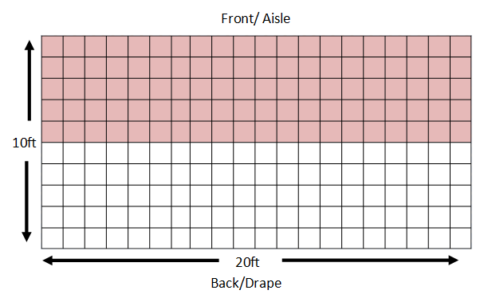
*Each box = 1 sq. ft.
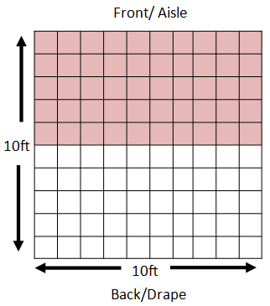
Booth Display Diagram – For Island Booths
Display Rules
- Items placed in the front half (i.e. 5ft) of your booth must be under 4ft tall. This is the shaded pink area.
- Tables and chairs should be placed in the back half of your booth, so your booth visitors are not congregating in the aisle.
- Floor standing objects must be no taller than 8ft.

Perimeter Booths
- The above display rules apply, except perimeter booths are permitted to have floor standing objects no taller than 12ft and may hang a banner at a height of 16ft from the floor to the bottom of the banner.

Island Booth
*Each box = 1 sq. ft.
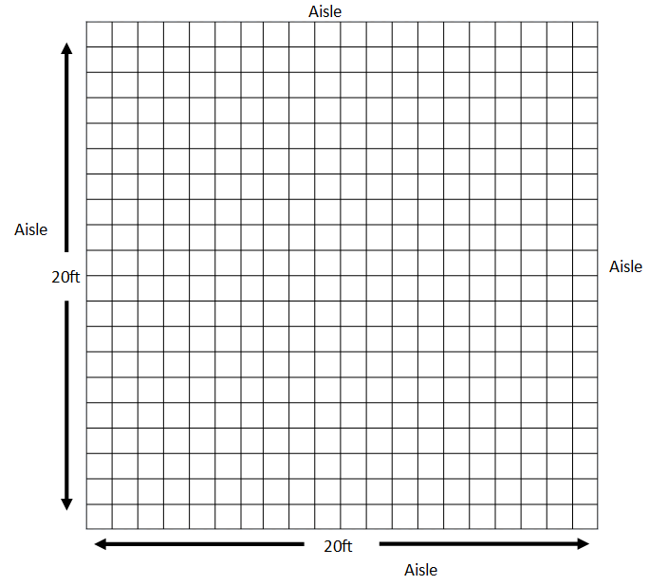

Emergency Contact Information Mandatory
Display Rules
The ceiling height in the exhibit hall is 18feet tall.
- Double-sided or rotating banners, signs, and graphics must be set at least 10ft away from other booths.
Deadline: May 2, 2022
Request for information. This form is available online.
Submit Online: https://tinyurl.com/yckpffsa

It is important that we have an onsite point-of-contact contact from your company for urgent issues while at the show. Please submit your onsite emergency contact online.

Submit Online: https://tinyurl.com/yckpffsa

Exhibitor & Sponsor Pre-Registration

Exhibitor registration can be accessed here: https://cvent.me/ZbM9w0?RefId=SPO
EXHIBITOR & Sponsor REGISTRATION PROCEDURES
Exhibitors will be allotted a certain number of complimentary conference badges. Please refer to your exhibitor agreement for your specific allotment. The badge form has been designed to register your staff. If you go over your allotment of badges for staff, you will need to purchase additional passes for $895.00 per person.
NEW REGISTRATION PROCEEDURE
You will be prompted for a code in the last step of your registration process. Your code is the FIRST 2 letters of your company name PLUS the first 4 digits of your company’s ZIP CODE. Once you add this code, your Order Total will equal $0, unless you have purchased additional passes.
EX. Bobit, 90503 = Exhibitor code B90503

If you have questions about your code or need assistance, please contact Marguerite Hoffman: marguerite.hoffman@bobit.com or 310-717-0633.

